
NORMAL OPERATING PROCEDURE (NOP)
& EMERGENCY ACTION PLAN (EAP)

RIPON RACECOURSE LAKE
(VERSION 3 – 15/05/25)

INTRODUCTION
The aim of this document is to provide a detailed overview of how each session will be operated and how incidents will be managed in a way that can be easily understood. It should be a blueprint for delivery that can be applied in the event of someone having to deputise for the regular organiser/session leader. It should be routinely referred to and not just left on a shelf to gather dust.
The document is split into three sections:
Section One: Normal Operating Procedures – provides background information in relation to the venue and activity as well as describing how safety will be managed routinely.
Section Two: Emergency Action Plan – describes the action that will be taken in the event of a foreseeable incident.
Section Three: Appendices – contains the risk assessment for the activity and other supporting documents referred to in the main document and/or risk assessment.

CONTENTS
NORMAL OPERATING PROCEDURES
Part One: Background Information
The Venue | Page 3
Venue Ownership, Organiser & Water Safety Provider | Page 3
Key Contacts & Responsibilities | Page 4
Event/Activity Description | Page 4
Site Plans | Page 5
Swimmer Tracking | Page 5
Entry and Exit | Page 5
Novice and Junior Swimmers | Page 6
Wetsuit Policy | Page 6
Water Temperature | Page 7
Water Quality | Page 7
Medical Arrangements | Page 8
Part Two: Water Safety Arrangements
Safety Cover Resourcing Levels & Positioning | Page 9
Communication Systems | Page 10
EAP | Page 12
Appendices | Page 13

Part One: Background Information
The Venue: Ripon Racecourse Lake
W3W to the site entrance: ///ticked.decisions.oiled
How to get to venue: Turn off the B6265 (Boroughbridge Road) at the Wetlands Entrance. Drive through the gateway and take a right at the gap in the racecourse. Follow the track to the grassed parking directly in front of the lake.
Facilities: There are no changing rooms or toilets available on site. Nudity is strictly forbidden so please ensure you have sufficient cover to get changed – either towels, dry-robes or inside your vehicle.
Venue Ownership, Organiser & Water Safety Provider:
The site is owned by the Ripon Racecourse Company and open water swimming sessions are operated by Ripon Triathlon Club volunteers.
Water safety Is provided by Ripon Triathlon Club in the form of COWS (Coordinators of Open Water Swimming), Spotters and Paddle Boarders who have attended the Paddle Board training session organised by the club.
UNDERSTANDING THE RISK
RTC will ensure that every club member fully understand these risks before being permitted to swim at Ripon Racecourse Lake. However, all swimmers agree to swim entirely at their own risk and in the unlikely event of injury, accident, loss or damage suffered, regardless of however it may be caused, no responsibility whatsoever shall be attached to the organisers, landlords, or any persons involved in the organisation of the open water swimming at Ripon Racecourse Lake.
Activity Organiser
Volunteer Roles
- OW Swim Manager
- COWS (Coordinators of Open Water Swimming)
- Spotters
- Paddle Boarders
The OW Manager is responsible for:
- Opening and closing the site
- Managing incidents should they occur.
- Weather monitoring and informing swimmers at the earliest possible time if sessions are cancelled.
- Checking the marker buoys are still in place
- Checking equipment – radios and paddle boards
The COWS are responsible for:
- Signing swimmers in and out of the water and ensuring they are RTC members
- Checking the temperature of the water
- Ensure parents have signed the disclaimer form for OW Junior Swimmers and confirm they have been competency assessed by OW Swim Committee member or BTF Certified Coach
- Ensure all swimmers have a tow float
- Ensure all swimmers adhere to the wetsuit guidelines
- Ensure swimmers have completed an Induction and understand the EAP
- Sound the Klaxon in the unlikely event of a major incident
- Complete an accident report form for any incident
- Coordinate the appropriate emergency response
The Spotters are responsible for:
- Keep constant visual contact with swimmers
- Watch for signs of distress, disorientation, fatigue, or swimmers veering off course.
- Communicating with the Safety Crew and alerting them of any issues
- Help confirm that all swimmers are accounted for during and after the swim
The Paddle Boarders are responsible for:
- Keep constant visual contact with swimmers
- Watch for signs of distress, disorientation, fatigue, or swimmers veering off course.
- Communicating with the Safety Crew and alerting them of any issues
- Stay near slower or more vulnerable swimmers if needed
- Assist any anxious or panicking swimmers
- Perform rescue procedures for conscious and unconscious swimmer in case of emergency.
Who/which organisation(s) has been involved in developing the NOPs/EAPs.
Senior members of staff (see key contacts) have been involved in the planning and development of open water activities including the risk assessment and documenting both normal and emergency operating procedures.
Key Contacts
Chair | Andrea McAuslan | 07793654445
OW Swim Manager | David Sharp | 07736808111
COWs | April Martin | 07376181480
COWs | Christine Marshall | 07303057940

Event/Activity Description
Ripon Triathlon Club sessions welcome all abilities and allow swimmers to train at their own pace around an accurately measured 250m and 500m course. Each session lasts for 2 hours and swimmers can complete as many or as few laps as they prefer. There is capacity for up to a maximum of 40 swimmers in the water at any time with 2 x Stand Up Paddle Boards. And up to 60 swimmers with 3 x Paddle Boarders. Maximum of 20 swimmers per Paddle Board.
The course is marked by 4 buoys and swimmers are to swim in a clockwise direction around the outside of these buoys. Once the bathing capacity has been reached no further swimmers can enter the water until space becomes available as swimmers exit the water. Ripon Triathlon Club welcomes swimmers over the age of 12 years, age related details and conditions are found in the appendices.
Swimming is only permitted:
- Between 1st April and 31ST Oct each year (dependant on water temp)
- Tuesdays and Thursdays 18:00-20:00 and Saturdays 08:00-09:30
- Once the water temperature is reliably above 12°C. Wetsuits are mandatory for adults AND children when water temperature is below 20°C (unless cleared to swim without a wet suit by Duty Manager following confirmation of experience), wetsuits become optional when the water temperature is over 20°C.
- There is a Club Open Water Supervisor present.
- You are a registered member of Ripon Triathlon Club on Spond (or you have arranged a free trial with COWS and have given all relevant information).

There are no other users of the lake whilst sessions are running. The banks slope to a uniform depth of around 2­3m. The lake is strictly private so should be free of items such as cans and bottles, although the lake is used by anglers and therefore a risk of fishing line. There are no known currents or eddies, overhanging or hidden underwater hazards in our designated swim areas. Please take care on entry and exit – it is more slippery when wet. Water temperature is generally uniform. The lake does have underwater weeds, nearer the surface in the warmer weather. These are visible, and advice is swim around rather than through.
Site Plans
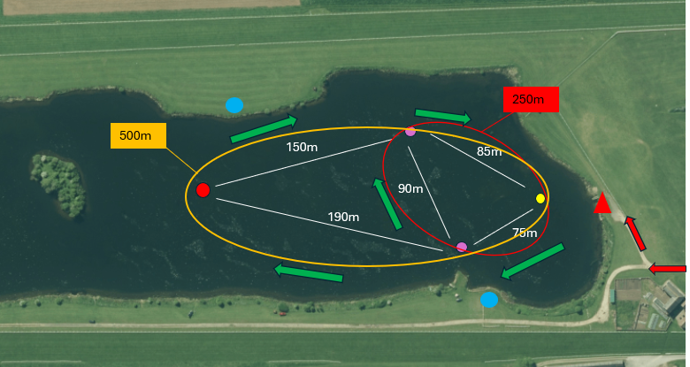
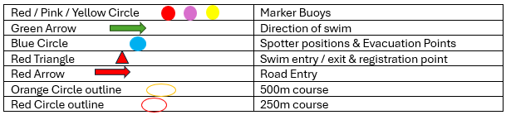
Swimmer Tracking
Swimmers to arrive and change by their cars or arrive changed and ready to swim. There are no changing rooms and there is a strict no-nudity rule. Once changed they are to sign in with the member of staff based at the swim entry point. This member of staff will have a membership list and access to the online database of those who have paid online (Spond). Any swimmer arriving without having paid will be directed to the payment app. We will not be accepting cash.
Each swimmer will then hand in their membership card or Photo ID in exchange for a swim band and are written in the registration book. If a photo ID is being used instead of Membership Card (if this has not been allocated in time), the COW will cross reference the ID with the Spond Membership App to confirm membership.
The COW on duty stays at the swim entry point for the entirety of the session to ensure to collect bands on exit from the water, reducing opportunity for ‘lost’ swimmers.
There are Paddle Boarders on the water at a 20:1 swimmer to PB ratio and 2 ‘Spotters’ based on either side of the lake. These safety crew are equipped with a radio and a whistle.
Once swimmers have finished their swim, they are to return their band to the COW in exchange for the membership card / Photo ID and then checked out in the registration book.
Entry and exit
Only enter and exit the lake via the wooden steps at the Entry/Exit point. There are two further evacuation points which can be used, both marked by flags. In the event of a controlled evacuation, the main Exit/Entry point is to be used.
Novice Swimmers
New swimmers must book an Induction via the Ripon Triathlon Club Members Forum (Facebook). On arrival the COWs will conduct the induction process prior to swimming.
For new members and for any members who wish to signify that they are not confident with OW swimming and would like to swim with another club member they will be given an orange swim hat.
Children

OW Junior members are only permitted to swim with a parent/guardian or a supervising Adult who is known to them and has the permission of the parent/guardian to swim with them. They must swim on a 1:1 ratio and remain within 5m of each other. They must have a signed parental declaration of their competence (see appendices).

The parent/guardian/supervising adult must be a Ripon Triathlon Club member, and have completed the induction training. Children must also hold a Junior OW Swim membership on Spond (this is separate to the Full Junior Membership that is a monthly fee managed through Membermojo) and they must also complete the induction training.

The recommended distances for each age group are:
- 12-year old – Max 350m
- 13 to 14-year old – Max 500m
- 15 to 16-year old – Max 750m
- 17-year old – Max 1,500m
- Wetsuits are mandatory
- Tow floats are mandatory

Wetsuit & Tow Float Policy
Wetsuits are mandatory for adults and children when water temperature is below 20°C (unless cleared to swim without a wet suit by Duty Manager following confirmation of experience), wetsuits become optional when the water temperature is over 20°.
All swimmers must use a tow float when OW swimming (either with or without a wetsuit), this provides them with an immediate buoyancy aid, and wave to attract attention, and should be easily recognisable to the safety crew.
Water Temperature
Water temperature is taken before each swim session.
Swimming is only permitted when the water temperature reliably exceeds 12°C and the safety arrangements for the lake are based on this presumption.
There is no minimum air temperature for swimming to be permitted. Safety crew advised to dress appropriately for the weather.
Water Quality
The water is tested at the beginning of the season and again in July. Samples are taken in line with the testing protocol set by Swim Safety who provide our water testing. Ripon Racecourse Lake has a long history of excellent water quality.
After the first over threshold reading, swimming sessions are postponed until further test results are confirmed. If high levels of bacteria are indicated on the re-test, the management team will discuss the best course of action and treatment, and the lake will be closed until conditions are within the acceptable range. In relation to blue- green algae, the lake is regularly monitored for visible signs of surface algae and tested as above.
If blue green algal blooms (any visual change to the water) are present, then swimming is suspended until further below thresholds tests have been received.
Duty Managers provide swimmers as much notice as possible.
Water quality tolerance limits are shown below.

EC Bathing Water Directive 2006/7/EC
Rating | Excellent | Good | Sufficient | Poor (Fail)
Escherichia coli (cfu/100 ml) | <500 | <1000 | <900 | >900
Intestinal enterococci  (cfu/100 ml) | <200 | <400 | <330 | >330

pH between 6 and 9
- Cyanobacteria 20,000-100,000 cell/ml (or if forming visual surface algae in swim areas)
- E’Coli not more than <900 per 100mils
- Entero-cocci <330 per 100mils

Blue Green Algae guidance Levels: No. Cells/ml | <20,000 | >20,000-<100,000 | >100,000
Rating | Relatively Low | Moderate (warning threshold) | High

Medical Arrangements
COWS are First Aid qualified. A defibrillator and First Aid equipment is located in the main store shed (this will be on hand for each session at the swim entry point with the COWS along with vehicle).
Address & contact details for nearest hospital with A & E department:
Harrogate District Hospital
Lancaster Park Road
Harrogate
HG2 7SX
01423 885959
During an incident the COWS on shift is responsible for ensuring emergency services have been contacted.
Emergency services are able to drive directly next to Lake if necessary. Handover point of casualties from the COWS to the medical support – emergency crews on site will alert Land based safety cover personnel to either continue or change over. Staff will defer to emergency service expertise in hand over situation.
Reporting:
All incident and near miss will be reported and investigations will be tasked to the Duty Manager.

PART TWO:
Water Safety Arrangements
Safety Cover Resourcing Levels and Positioning
Maximum number of Swimmers at any one time: 60.
Number of engine- powered craft (safety boat) – N/A
Number of human-powered craft:
1 x COWS
2 x Land-based Spotters
Paddle Boarders on the water (ratio of 20:1 swimmers:PB). Minimum of two Paddle Boarders.
COWS on swim entry to manage, sign in and out, first aid, emergency response and general information for swimmers at swim entry location. When not signing swimmers in and out the COW will coordinate regular swim counts and can be an additional pair of eyes for spotter duties.
At the beginning of the session the COW at point of entry will ensure that no swimmers enter the water until safety cover is in position and have overall responsibility for the session.
Paddle Boarder will:
- Provide assistance at all entry/exit points if required and monitor swimmers’ ability where necessary.
- Will move up and down swim sections ensuring they are responsive to swimmer requirements.
- In an emergency event, if required the on-water PB will encourage swimmers to exit at the nearest bank and walk back around to entry point.
- Look for signs of swim failure in cold swimmers and assess the swimmer’s ability to continue safely.
- Raise the alarm and summon support (via walkie talkies) in the event of discovering an unconscious swimmer in the water.
- Provide support to conscious swimmers who get into difficulty and returning to the nearest bank.
- Recover unconscious swimmers to the nearest bank.
- Paddle boarder will have a whistle and radio.
Spotters will:
- Monitor swimmer activity and spot signs of distress through use of binoculars.
- Alert Paddle Boarder and COW of any swimmers with signs of distress or requiring assistance.
- Spotters will move to the evacuation point to retrieve distressed / unconscious swimmer to land.
- Confirm regular swim counts with COW.
- Will have a whistle, radio and binoculars.
Notice board is used at Swim Entry to inform new and regular swimmers of general swimmer information and checklist, swimmer signals, water temperature, swim route and length, emergency protocols and whistle blast meanings.
Positioning
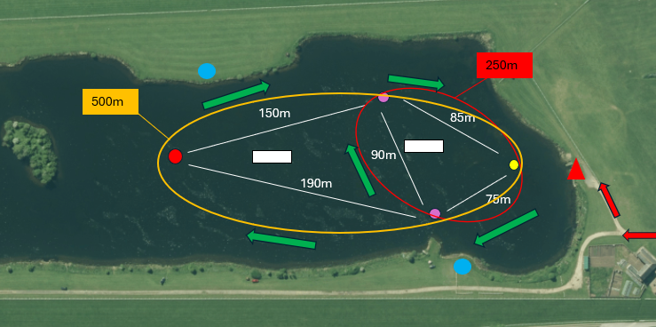
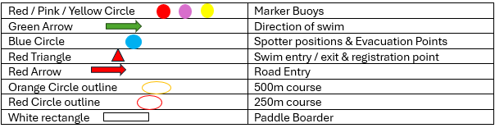
Spotters:
COW – at swim entry
Spotter 1 - on the East side of the lake at the inlet near the first Island
Spotter 2 - on the West side of the lake at the inlet by the wooden steps
Paddle Boarders:
Paddle Boarder 1 will remain within the bottom half of the course between the red and pink buoys.
Paddle Boarder 2 will remain within the top half of the course between the yellow and pink buoys.
Communication System
The communication system for the water safety team will comprise of radio communication with whistles being used as a backup as well as an air horn.
Communication between the water safety team and swimmers in the water will be whistle signals and verbal Instructions.
If swimmers need to get the attention of the safety crew they are to stop and wave one hand in the air and shout if they are able to.
Spotter and paddle boarders to use radios to communicate with each other and the COWS with a whistle as a back- up method of communication.
1 short whistle blast – to get the attention of a swimmer
2 short whistle blasts – to get the attention of another Safety Crew member
1 long blow of the air horn – to evacuate the lake
Water Safety Team Briefing
Pre-season
The water safety team will be sent a copy of the NOP & EAP ahead of the season and a run-through of these practices will take place prior to the start of the season.
Further training/practice will be arranged during the season including as/when new members join the team to include Paddle Board refresher sessions.
Pre-session
Prior to each session the Duty Manager and COWS will ensure the safety team are aware of their responsibilities.
‘2nd Island’ (Longer course Swim)
On pre-arranged dates during the year there will be the option to swim the full 1500m course of the lake.
Long course sessions will take place during the normal Thursday evening sessions where all normal operating procedures remain the same. The normal 250m and 500m courses are still available to swim at this time.
On these dates additional cover has been arranged and will be provided by the Dales Canoe Club who have all received water rescue training.
6 canoeists will be provided and will be stationed as per the diagram below.
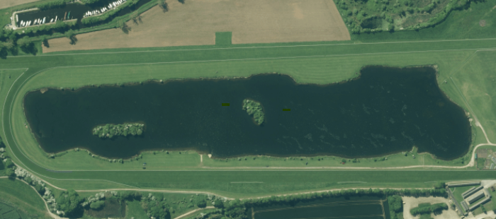
1500mm
Green Arrow | Direction of swim
Yellow Circle | Spotter positions
Red Triangle | Swim entry / registration point
Orange Rectangle | Canoeist
Yellow oval ouline | 1500m Course

EMERGENCY ACTION PLAN
Recovery of a conscious casualty
The Paddle Boarder closest to the swimmer to encourage them to swim to the bank. The lifeguard should position themselves where the swimmer can see them and direct the swimmer towards them.
If established the swimmer cannot swim themselves to the bank, the PB should use the radio to get the attention of the COWS and the other safety team before entering the water. At this point the COW is to ensure that the lake is still being effectively supervised. The PB enters the water and carries out the appropriate rescue which is covered in the site-specific training. Once initial first aid checks have been made, the swimmer should be escorted back to the swim entry and checked over by the COWS, allowing the PB to return to their stations. An incident form will be filled out if required.
Recovery of an unconscious, non-breathing casualty
PB closest to swimmer to alert the COWS and other safety team, via radio before entering the water to perform a rescue. COWS to blow klaxon to signal a lake evacuation. OW manager to manage the evacuation and to then meet emergency services and direct them to the casualty.
The PB is to bring the casualty back to the closest bank, casualty taken out of the lake and CPR to commence. The COWS will take control of the scenario, safety team should remain radio silence so that all messages can get through. The COWS to take first aid kit and defibrillator round to the unconscious casualty whilst phoning for the emergency services.
COWS to continue with CPR/first aid until emergency services arrive. Once lake has been evacuated, remaining safety team to await further Instructions from COWS / OW Manager.
Missing swimmer
Swimmers to drop bands back at swim entry finishing their swim so they can be signed out of the water. Periodic checks between COWS, PB and Spotters to check number of bands signed out correlates with the number of swimmers in the water.
If a swimmer is recorded as missing, then a quick search of facilities undertaken.
If a swimmer still unaccounted for, a phone call to their mobile number to be made, number available on the membership list and on the Spond App.
If contact cannot be made, then a call to their listed next of kin to be made, available on the membership list and on the Spond App.
If contact still cannot be made, then a thorough search of the facility will be conducted, and emergency services called (OW Manager will coordinate).
Course Evacuation e.g. lightning, declining visibility, lifeguard performing in water rescue
In the event of Lake evacuation, air horn will sound and PBs will encourage swimmers to exit the water at the nearest point.
There will be no revised course as we cannot effectively manage swimmers in other configurations without boat based support.
Session to be cancelled with as much prior notice if water temp falls below 12° or if water quality samples come back positive for algae or coliforms or if lightning predicted.

Appendices
- EAP
- Junior Swimming Guidance and Competency
- OW Swimming Declaration of Competence
- OW Induction
- Advisory Health Document
- Club Open Water Supervisor Guidelines
- Spotter and Paddle Boarder Guidelines
- Water Testing Results

